 | E-Gov Link
Affordable E-Government Solutions

- E-Gov Link™ enables local governments to take advantage of Internet technology by using pre-built e-government applications available at a fraction of the cost of custom development. Yet these applications are flexible enough to provide for your unique needs.
- E-Gov Link can be set up quickly on our computers with few demands on your staffs’ time. Affordable annual fees are renewable each calendar year to match budgeting cycles. E-Gov Link can also be licensed to run on your in-house computers.
- E-Gov Link is integrated with your current website, using your logo and colors. All E-Gov Link functions can be accessed from a single link on your website. You can also link directly to individual functions (and documents). Every E-Gov Link page links back to your website.

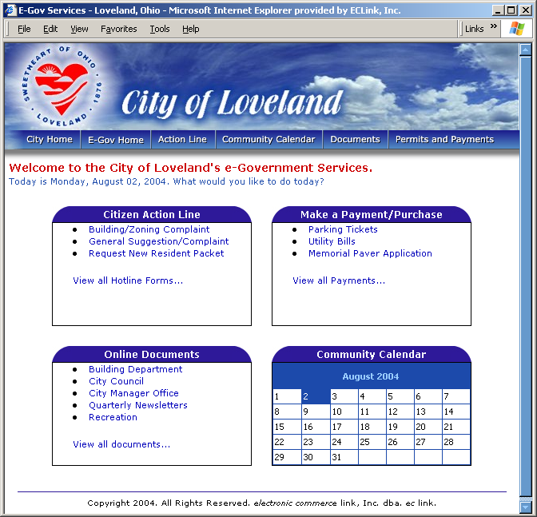

E-Gov Modules

Citizen Action Line provides a way for residents and local business to use the Internet to make suggestions, request information, and request action. Users select the type of action requested. The appropriate web form is displayed for the user to complete. If they include their email address, you will be able to provide information and status updates. All requests are tracked in a central database. Based on the request type, specific individuals on your staff can be notified, so they can follow-up on each request and record the results in the database. Flexible management reporting offers summaries or details of all items or just open items. This tool can also be used by internal staff as a central repository for requests that come by phone or fax.

Community Calendar allows non-technical staff to maintain a public calendar with information about all your events. Month calendar display shows name of event in date box. Users click to details in date sequence below. Future or previous month’s events can also be displayed.

Document Management provides an easy way for the public to find documents to your website. Non-technical staff can easily add and organize them. Documents can be uploaded from any PC by any authorized user. Document search makes it easy to find the desired document. Documents are grouped by categories in familiar Microsoft-style folders. Folders may contain sub-folders to any number of levels to further organize documents. You have full control over creating and naming folders, sub-folders and documents. Documents can be HTML, PDF, Word, Excel, or other popular document types.

Permits and Payments provides an easy way for the public to use on-line forms to apply for permits and make various types of payments. E-Gov Link comes standard with many popular form types. Others can be added at a low cost. Payments can be made via credit card. A convenience fee maybe added, if desired. Permit and payment database enables status monitoring and reporting. Each permit or payment action can be set to notify the right department or person for follow-up. Emails can also be sent back to the requestors with receipts or permit forms.

More modules are in development. Tell us about your specific needs.

Why Use E-Gov Link?

- You’ve made substantial investments in information technology. E-Gov Link provides visible benefits to the public to leverage that investment.
- You can start-up quickly and at low cost with few demands on internal resources.
- Add new functionality as needed in the future.
- No long-term commitment.
- E-Gov Link is developed and offered by ec link. ec link has been providing information technology solutions since 1996. Clients include dozens of governments and financial institutions around the country.
- Complementary applications, including E-Gov StaffLink are also available.

